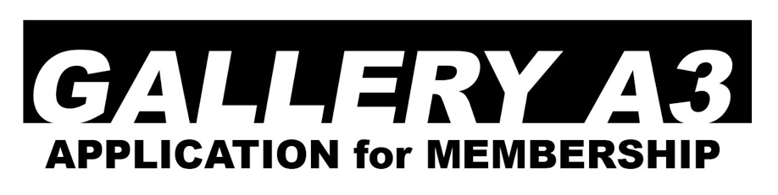

MISSION STATEMENT
We are a contemporary, cooperative fine art gallery.
The mission of Gallery A3 is:
- to enrich our lives with an alliance of established professional and emerging artists,
- to encourage members to exhibit exciting new work,
- to enliven our community by offering monthly exhibits, openings/artwalks and open forums.

MATERIALS FOR REVIEW
Materials must be submitted by email to gallerya3@gmail.com with hard copies and original work delivered
to the gallery. Submit:
- five original, recent works plus an additional 10-15 images on disc or flash drive,
- a resume and brief artist's statement and biography,
- a numbered list of images or order of appearance—include size, materials and date,
- a brief explanation of your interest in joining the gallery.

YEARLY MEMBERSHIP LEVEL & BENEFITS
- OPPORTUNITIES & BENEFITS
Showing in Gallery A3, GoBerry and Amherst Cinema. Promotion of your show through press releases, Facebook and Instagram, gallery website, gallery portfolio book. Sale of your art during in-gallery shows and from the online store. When you have a show, opening reception and artist forums help. Networking with professionals, making new art friends and having fun! Only 25% commission to the gallery on all sales.
- FULL membership $575
solo and two-person shows, group shows. Job, gallery sitting, voting.
- HALF membership $375
two-person shows, group shows. Job, gallery sitting, voting.
- ASSOCIATE membership $275
all group shows. No job, no sitting, no voting.

APPLICANT

name ________________________________________________________________________________

address______________________________________________________________________________

city state zip__________________________________________________________________________

preferred phone_______________________________________________________________________

email________________________________________________________________________________

_____________________________________________________________________________________
SIGNATURE Date

Gallery A3, 28 Amity Street 1D, Amherst, MA 01002
413 256-4250, www.gallerya3.com, gallerya3@gmail.com
Thursday-Sunday 3-7 pm (currently 2021)

